Double Materiality Matrix

A Double Materiality Matrix is a framework used in sustainability reporting and corporate disclosure to analyze and communicate the environmental, social, and governance impacts of an organization's activities.
Double materiality within ESG requires companies to report both on how their business is impacted by sustainability issues and how their activities impact society and the environment.
By identifying the most important ESG issues based on both financial and sustainability considerations, the Double Materiality Matrix enables companies to better understand the interconnectedness between financial performance and ESG impacts and to engage with stakeholders on these critical issues.
What To Include in a Double Materiality Matrix?
The purpose of a Double Materiality Matrix is to:
- Define shortlist of ESG priorities for a company, based on both financial and impact materiality.
- Understand what ESG areas to lead, follow or monitor, based on company “strengths” and “weaknesses”.
Why is a Double Materiality Matrix Assessment Important for your Company?
Take a moment to read a conversation between some professionals discussing their knowledge of the Double Materiality Assessment to learn more about its importance.
Having issues reviewing the interactive graphic? Access an accessible version of Double Materiality Matrix Assessment Conversation.

Double Materiality Matrix Conversation
Take a moment to read a conversation between two professionals discussing their knowledge of the Double Materiality Assessment.

- James: Hey Emma, how do you do double materiality assessment at your company?
- Emma: I know what materiality is, but I’ve just heard of the double materiality assessment. What is it all about?
- James: It’s a framework to evaluate a company’s impact on ESG factors. Basically, you need to assess your impact on an ongoing basis. It’s key to understand the context where your company operates, potential impacts, and how these could be significant for your company. For instance, at my supermarket we decided to reduce most single plastic products because we analyzed our context and understood that a lot of the plastic that ended up in the local lake came from our products. Obviously, we didn’t throw it there, but people used to leave it and we decided to sort the plastic issue from where it started.
- Emma: I see. You identified potential impacts, for instance, the impact that plastic pollution could have meant for your license to operate in your community and the ecological impact, and you took proactive measures to mitigate risks.
- James: Exactly, and not only that: assessing which impacts were most significant helped us prioritize the most crucial ones for setting specific initiatives.
- Emma: What do you mean? Don’t you need to consider all impacts related to ESG?
- James: It would be too hard to do so, so you need to prioritize the most significant impacts.
- Emma: And how do you do that?
- James: You build a Materiality Matrix. Identify key ESG issues, assess how important they are for the business and its different stakeholders, and plot them on a map. The ones more important for all stakeholders are the most material ones, the ones you need to prioritize.
- Emma: It does make sense. I guess that you also need to communicate the material topics for transparency?
- James: Sure! If you don’t follow the whole process and communicate it properly, you might come across greenwashing claims.
- Emma: Can you mention an example of a company that does it correctly?
- James: Check Unilever and their double materiality assessment. They identified their material ESG issues, considering both the impacts their business has on society and the impacts society has on their business.
- Emma: That's interesting and it sounds like a comprehensive approach to assess and address ESG impacts.
- James: Absolutely! It's about managing risks and opportunities, building trust and creating long-term value.

Why is a Double Materiality Assessment Relevant?
- Identifying impacts means that a company can take proactive measures to mitigate risks and seize opportunities related to those impacts.
- Once you identify the significant impacts, then you need to validate the results with relevant stakeholders.
- Assessing the significance of impacts helps prioritize the most crucial ones for setting initiatives.
Two Key Pillars of the Double Materiality Assessment
The 2 key pillars of Double Materiality Assessment for organizations identify and determine the following:
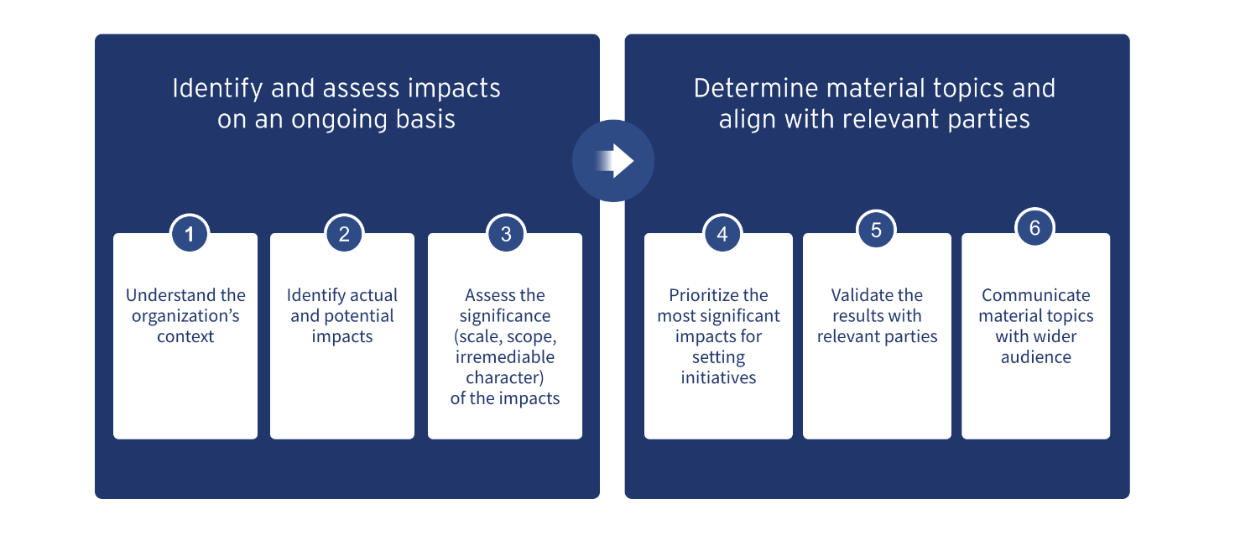
Part A: Identify and assess impacts on an ongoing basis
1. Understand the organization's context
2. Identify actual and potential impacts
3. Assess the significance (scale, scope, irremediable character) of the impacts
Part B: Determine material topics and align with relevant parties
4. Prioritize the most significant impacts for setting initiatives
5. Validate the results with relevant parties
6. Communicate material topics with wider audiences

